Name : Rajvardhan Reddy
Reg No : 180905093
Sec : B
Roll No : 19

CD LAB 8 : RD Parser for Array Declarations and Expression Statements
&
CD LAB 9 : RD Parser for Decision Making and Looping Statements

LAB 8 :

P1) Design the recursive descent parser to parse array declarations and expression statements with error reporting. Subset of grammar 7.1 is as follows:
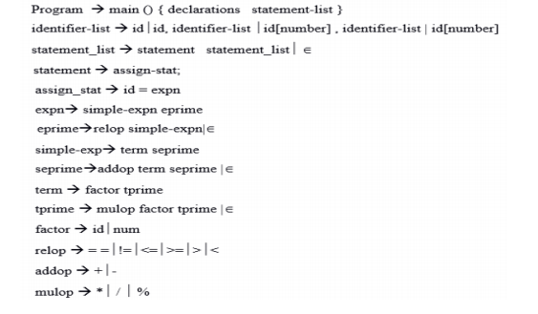

lex.c :

#include <stdlib.h>
#include <stdio.h>
#include <ctype.h>
#include <string.h>

static int row=1,col=1;
char buf[2048];
char dbuf[128];
int ind=0;

const char specialsymbols[]={'?',';',':',','};
const char arithmeticsymbols[]={'*'};
const char *keywords[] = {"auto", "double", "int", "struct", "break", "else", "long", "switch", "case", "enum", "register", "typedef", "char", "extern", "return", "union", "continue", "for", "signed", "void", "do", "if", "static", "while", "default", "goto", "sizeof", "volatile", "const", "short", "unsigned", "printf", "scanf", "true", "false", "bool"};
const char *datypes[] = {"int","char","void","float","bool","double"};

struct token
{
char lexeme[128];
unsigned int row,col;
char type[64];
};

struct sttable
{
int sno;
char lexeme[128];
char dtype[64];
char type[64];
int size;
};

int isKeyword(char *w)
{

for(int i=0;i<sizeof(keywords)/sizeof(char*);i++)
if(strcmp(w,keywords[i])==0)
return 1;
return 0;
}

int isdtype(char *w)
{
for(int i=0;i<sizeof(datypes)/sizeof(char*);i++)
if(strcmp(w,datypes[i])==0)
return 1;
return 0;
}

void newLine()
{
++row; col=1;
}

void printTable(struct sttable *tab,int n)
{
for(int i=0;i<n;i++)
printf("%d %s %s %s %d\n",tab[i].sno,tab[i].lexeme,tab[i].dtype,tab[i].type,tab[i].size);
}

int findTable(struct sttable *tab,char *nam,int n)
{
for(int i=0;i<n;i++)
if(strcmp(tab[i].lexeme,nam)==0)
return 1;
return 0;
}

struct sttable fillTable(int sno,char *lexn,char *dt,char *t,int s)
{
struct sttable tab;
tab.sno=sno;
strcpy(tab.lexeme,lexn);
strcpy(tab.dtype,dt);
strcpy(tab.type,t);
tab.size=s;
return tab;
}

void fillToken(struct token *tkn,char c,int row,int col, char *type)
{
tkn->row=row;
tkn->col=col;
strcpy(tkn->type,type);
tkn->lexeme[0]=c;
tkn->lexeme[1]='\0';
}

int charIs(int c,const char *arr)
{
int len;
if(arr==specialsymbols)
len=sizeof(specialsymbols)/sizeof(char);

else if(arr==arithmeticsymbols)
len=sizeof(arithmeticsymbols)/sizeof(char);

for(int i=0;i<len;i++)
if(c==arr[i])
return 1;
return 0;
}

int sz(char *w)
{
if(strcmp(w,"int")==0)
return sizeof(int);
if(strcmp(w,"char")==0)
return sizeof(char);
if(strcmp(w,"void")==0)
return 0;
if(strcmp(w,"float")==0)
return sizeof(float);
if(strcmp(w,"bool")==0)
return 1;
}

struct token getNextToken(FILE *fa)
{
int c;
struct token tkn=
{
.row=-1
};
int gotToken=0;

while(!gotToken && (c=fgetc(fa))!=EOF)
{
if(charIs(c,specialsymbols))
{
fillToken(&tkn,c,row,col,"SS");
gotToken=1;
++col;
}
else if(charIs(c,arithmeticsymbols))
{
fseek(fa,-1,SEEK_CUR);
c=getc(fa);
if(isalnum(c)){
fillToken(&tkn,c,row,col,"ARITHMETICOPERATOR");
gotToken=1;
++col;
}
fseek(fa,1,SEEK_CUR);
}
else if(c=='(')
{
fillToken(&tkn,c,row,col,"LB");
gotToken=1;
col++;
}
else if(c==')')
{
fillToken(&tkn,c,row,col,"RB");
gotToken=1;
col++;
}
else if(c=='{')
{
fillToken(&tkn,c,row,col,"LC");
gotToken=1;
col++;
}
else if(c=='}')
{
fillToken(&tkn,c,row,col,"RC");
gotToken=1;
col++;
}
else if(c=='[')
{
fillToken(&tkn,c,row,col,"LS");
gotToken=1;
col++;
}
else if(c==']')
{
fillToken(&tkn,c,row,col,"RS");
gotToken=1;
col++;
}
else if(c=='+')
{
int x=fgetc(fa);
if(x!='+')
{
fillToken(&tkn,c,row,col,"ARITHMETICOPERATOR");
gotToken=1;
col++;
fseek(fa,-1,SEEK_CUR);
}
else
{
fillToken(&tkn,c,row,col,"UNARYOPERATOR");
strcpy(tkn.lexeme,"++");
gotToken=1;
col+=2;
}
}
else if(c=='-')
{
int x=fgetc(fa);
if(x!='-')
{
fillToken(&tkn,c,row,col,"ARITHMETICOPERATOR");
gotToken=1;
col++;
fseek(fa,-1,SEEK_CUR);
}
else
{
fillToken(&tkn,c,row,col,"UNARYOPERATOR");
strcpy(tkn.lexeme,"++");
gotToken=1;
col+=2;
}
}
else if(c=='=')
{
int x=fgetc(fa);
if(x!='=')
{
fillToken(&tkn,c,row,col,"ASSIGNMENTOPERATOR");
gotToken=1;
col++;
fseek(fa,-1,SEEK_CUR);
}
else
{
fillToken(&tkn,c,row,col,"RELATIONALOPERATOR");
strcpy(tkn.lexeme,"++");
gotToken=1;
col+=2;
}
}
else if(isdigit(c))
{
fillToken(&tkn,c,row,col++,"NUMBER");
int j=1;
while((c=fgetc(fa))!=EOF && isdigit(c))
{
tkn.lexeme[j++]=c;
col++;
}
tkn.lexeme[j]='\0';
gotToken=1;
fseek(fa,-1,SEEK_CUR);
}
else if(c == '#')
{
while((c = fgetc(fa))!= EOF && c != '\n');
newLine();
}
else if(c=='\n')
{
newLine();
c = fgetc(fa);
if(c == '#')
{
while((c = fgetc(fa)) != EOF && c != '\n');
newLine();
}
else if(c != EOF)
{
fseek(fa, -1, SEEK_CUR);
}
}
else if(isspace(c))
++col;
else if(isalpha(c) || c=='_')
{
tkn.row=row;
tkn.col=col++;
tkn.lexeme[0]=c;
int j=1;
while((c=fgetc(fa))!=EOF && isalnum(c))
{
tkn.lexeme[j++]=c;
col++;
}
tkn.lexeme[j]='\0';
if(isKeyword(tkn.lexeme))
strcpy(tkn.type,"KEYWORD");
else
strcpy(tkn.type,"IDENTIFIER");
gotToken=1;
fseek(fa,-1,SEEK_CUR);
}
else if(c=='/')
{
int d=fgetc(fa);
++col;
if(d=='/')
{
while((c=fgetc(fa))!= EOF && c!='\n')
++col;
if(c=='\n')
newLine();
}
else if(d=='*')
{
do
{
if(d=='\n')
newLine();
while((c==fgetc(fa))!= EOF && c!='*')
{
++col;
if(c=='\n')
{
newLine();
}
}
++col;
}while((d==fgetc(fa))!= EOF && d!='/' && (++col));
++col;
}
else
{
fillToken(&tkn,c,row,--col,"ARITHMETIC OPERATOR");
gotToken=1;
fseek(fa,-1,SEEK_CUR);
}
}
else if(c=='"')
{
tkn.row=row;
tkn.col=col;
strcpy(tkn.type, "STRING LITERAL");
int k = 1;
tkn.lexeme[0] = '"';
while((c = fgetc(fa)) != EOF && c != '"')
{
tkn.lexeme[k++] = c;
++col;
}
tkn.lexeme[k] = '"';
gotToken = 1;
}
else if(c == '<' || c == '>' || c == '!')
{
fillToken(&tkn, c, row, col, "RELATIONALOPERATOR");
++col;
int d = fgetc(fa);
if(d == '=')
{
++col;
strcat(tkn.lexeme, "=");
}
else
{
if(c == '!')
{
strcpy(tkn.type, "LOGICALOPERATOR");
}
fseek(fa, -1, SEEK_CUR);
}
gotToken = 1;
}
else if(c == '&' || c == '|')
{
int d = fgetc(fa);
if(c == d)
{
tkn.lexeme[0] = tkn.lexeme[1] = c;
tkn.lexeme[2] = '\0';
tkn.row = row;
tkn.col = col;
++col;
gotToken = 1;
strcpy(tkn.type, "LOGICALOPERATOR");
}
else
{
fseek(fa, -1, SEEK_CUR);
}
++col;
}
else
++col;
}
return tkn;
}

l8.c:

#include "lex.c"

void program();
void declarations();
void datatype();
void idlist();
void idlistprime();
void assignstat();
void statementlist();
void statement();
void expn();
void eprime();
void simpleexp();
void seprime();
void term();
void tprime();
void factor();
void relop();
void addop();
void mulop();

struct token tkn;
FILE *f1;
char *rel[] = {"==", "!=", "<=", ">=", ">", "<"};
char *add[] = {"+", "-"};
char *mul[] = {"*", "/", "%"};

int isrel(char *w)
{
int i;
for (i = 0; i < sizeof(rel) / sizeof(char *); i++)
if (strcmp(w, rel[i]) == 0)
return 1;
return 0;
}

int isadd(char *w)
{
int i;
for (i = 0; i < sizeof(add) / sizeof(char *); i++)
if (strcmp(w, add[i]) == 0)
return 1;
return 0;
}

int ismul(char *w)
{
int i;
for (i = 0; i < sizeof(mul) / sizeof(char *); i++)
if (strcmp(w, mul[i]) == 0)
return 1;
return 0;
}

int main()
{
FILE *fa, *fb;
int ca, cb;
fa = fopen("l8input.c", "r");
if (fa == NULL)
{
printf("Cannot open file \n");
exit(0);
}

fb = fopen("l8output.c", "w+");
ca = getc(fa);
while (ca != EOF)
{
if (ca == ' ')
{
putc(ca, fb);
while (ca == ' ')
ca = getc(fa);
}
if (ca == '/')
{
cb = getc(fa);
if (cb == '/')
{
while (ca != '\n')
ca = getc(fa);
}
else if (cb == '*')
{
do
{
while (ca != '*')
ca = getc(fa);
ca = getc(fa);
} while (ca != '/');
}
else
{
putc(ca, fb);
putc(cb, fb);
}
}
else
putc(ca, fb);
ca = getc(fa);
}
fclose(fa);
fclose(fb);

fa = fopen("l8input.c", "r");
if (fa == NULL)
{
printf("Cannot open file");
return 0;
}
fb = fopen("temp.c", "w+");
ca = getc(fa);
while (ca != EOF)
{
if (ca == '"')
{
putc(ca, fb);
ca = getc(fa);
while (ca != '"')
{
putc(ca, fb);
ca = getc(fa);
}
}
else if (ca == '#')
{

while (ca != '\n')
{

ca = getc(fa);
}
ca = getc(fa);
}
putc(ca, fb);
ca = getc(fa);
}
fclose(fa);
fclose(fb);

fa = fopen("temp.c", "r");
fb = fopen("l8output.c", "w");
ca = getc(fa);
while (ca != EOF)
{
putc(ca, fb);
ca = getc(fa);
}
fclose(fa);
fclose(fb);
remove("temp.c");

f1 = fopen("l8output.c", "r");
if (f1 == NULL)
{
printf("Error! File cannot be opened!\n");
return 0;
}
while ((tkn = getNextToken(f1)).row != -1)
{
if (strcmp(tkn.lexeme, "main") == 0)
{
program();
break;
}
}
fclose(f1);
}

void program()
{

if (strcmp(tkn.lexeme, "main") == 0)
{
tkn = getNextToken(f1);
if (strcmp(tkn.lexeme, "(") == 0)
{
tkn = getNextToken(f1);
if (strcmp(tkn.lexeme, ")") == 0)
{
tkn = getNextToken(f1);
if (strcmp(tkn.lexeme, "{") == 0)
{
tkn = getNextToken(f1);
declarations();
statementlist();
if (strcmp(tkn.lexeme, "}") == 0)
{
printf("Compilation successful\n");
return;
}
else
{
printf("} missing at row=%d col=%d", tkn.row, tkn.col);
exit(1);
}
}
else
{
printf("{ missing at row=%d col=%d", tkn.row, tkn.col);
exit(1);
}
}
else
{
printf(") missing at row=%d col=%d", tkn.row, tkn.col);
exit(1);
}
}
else
{
printf("( missing at row=%d col=%d", tkn.row, tkn.col);
exit(1);
}
}
}
void declarations()
{
if (isdtype(tkn.lexeme) == 0)
{
return;
}
datatype();
idlist();
if (strcmp(tkn.lexeme, ";") == 0)
{
tkn = getNextToken(f1);
declarations();
}
else
{
printf("; missing at row=%d col=%d", tkn.row, tkn.col);
exit(1);
}
}
void datatype()
{
if (strcmp(tkn.lexeme, "int") == 0)
{
tkn = getNextToken(f1);
return;
}
else if (strcmp(tkn.lexeme, "char") == 0)
{
tkn = getNextToken(f1);
return;
}
else
{
printf("%s Missing datatype at row=%d col=%d", tkn.lexeme, tkn.row, tkn.col);
exit(1);
}
}
void idlist()
{
if (strcmp(tkn.type, "IDENTIFIER") == 0)
{
tkn = getNextToken(f1);
idlistprime();
}
else
{
printf("Missing IDENTIFIER at row=%d col=%d", tkn.row, tkn.col);
}
}
void idlistprime()
{
if (strcmp(tkn.lexeme, ",") == 0)
{
tkn = getNextToken(f1);
idlist();
}
if (strcmp(tkn.lexeme, "[") == 0)
{
tkn = getNextToken(f1);
if (strcmp(tkn.type, "NUMBER") == 0)
{
tkn = getNextToken(f1);
if (strcmp(tkn.lexeme, "]") == 0)
{
tkn = getNextToken(f1);
if (strcmp(tkn.lexeme, ",") == 0)
{
tkn = getNextToken(f1);
idlist();
}
else
{
return;
}
}
}
}
else
{
return;
}
}
void statementlist()
{
if (strcmp(tkn.type, "IDENTIFIER") != 0)
{
return;
}
statement();
statementlist();
}
void statement()
{
assignstat();
if (strcmp(tkn.lexeme, ";") == 0)
{
tkn = getNextToken(f1);
return;
}
}
void assignstat()
{
if (strcmp(tkn.type, "IDENTIFIER") == 0)
{
tkn = getNextToken(f1);
if (strcmp(tkn.lexeme, "=") == 0)
{
tkn = getNextToken(f1);
expn();
}
else
{
printf("= missing at row=%d col=%d", tkn.row, tkn.col);
exit(1);
}
}
else
{
printf("Missing IDENTIFIER at row=%d col=%d", tkn.row, tkn.col);
exit(1);
}
}
void expn()
{
simpleexp();
eprime();
}
void eprime()
{
if (isrel(tkn.lexeme) == 0)
{
return;
}
relop();
simpleexp();
}
void simpleexp()
{
term();
seprime();
}
void seprime()
{
if (isadd(tkn.lexeme) == 0)
{
return;
}
addop();
term();
seprime();
}
void term()
{
factor();
tprime();
}
void tprime()
{
if (ismul(tkn.lexeme) == 0)
{
return;
}
mulop();
factor();
tprime();
}
void factor()
{
if (strcmp(tkn.type, "IDENTIFIER") == 0)
{
tkn = getNextToken(f1);
return;
}
else if (strcmp(tkn.type, "NUMBER") == 0)
{
tkn = getNextToken(f1);
return;
}
}
void relop()
{
if (strcmp(tkn.lexeme, "==") == 0)
{
tkn = getNextToken(f1);
return;
}
if (strcmp(tkn.lexeme, "!=") == 0)
{
tkn = getNextToken(f1);
return;
}
if (strcmp(tkn.lexeme, "<=") == 0)
{
tkn = getNextToken(f1);
return;
}
if (strcmp(tkn.lexeme, ">=") == 0)
{
tkn = getNextToken(f1);
return;
}
if (strcmp(tkn.lexeme, "<") == 0)
{
tkn = getNextToken(f1);
return;
}
if (strcmp(tkn.lexeme, ">") == 0)
{
tkn = getNextToken(f1);
return;
}
}
void addop()
{
if (strcmp(tkn.lexeme, "+") == 0)
{
tkn = getNextToken(f1);
return;
}

if (strcmp(tkn.lexeme, "-") == 0)
{
tkn = getNextToken(f1);
return;
}
}

void mulop()
{

if (strcmp(tkn.lexeme, "*") == 0)
{
tkn = getNextToken(f1);
return;
}

if (strcmp(tkn.lexeme, "/") == 0)
{
tkn = getNextToken(f1);
return;
}

if (strcmp(tkn.lexeme, "*") == 0)
{
tkn = getNextToken(f1);
return;
}

}

INPUT :

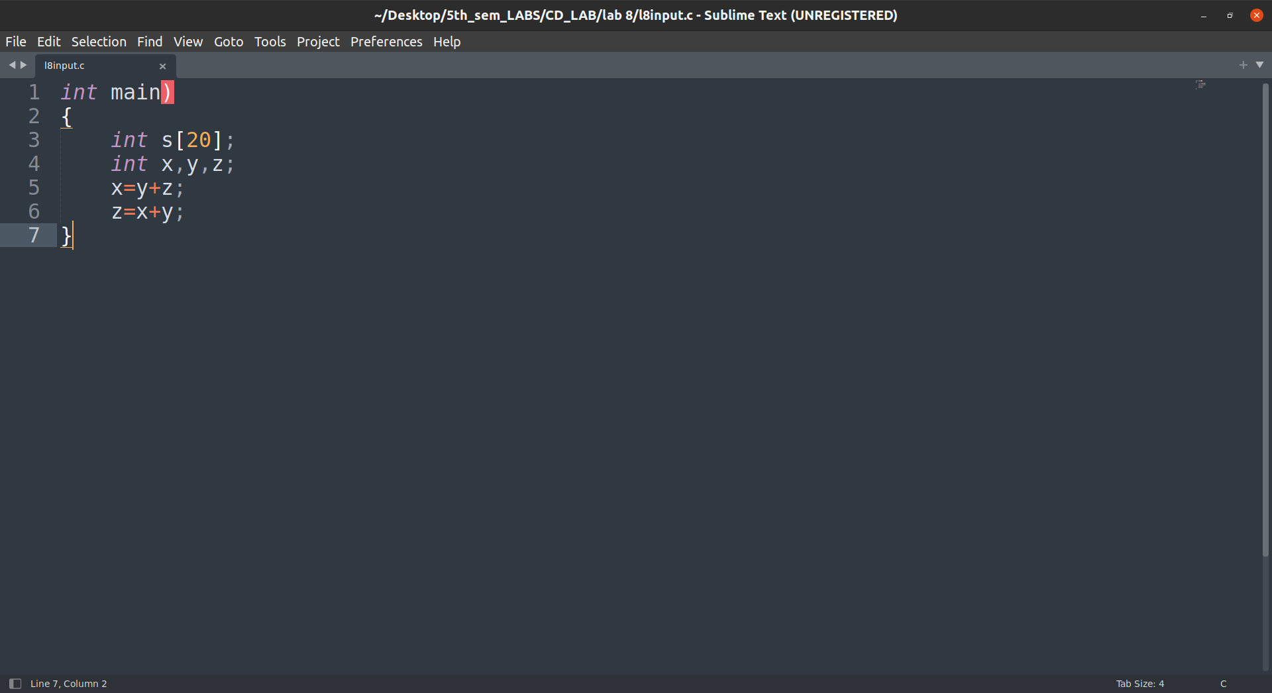

Output :

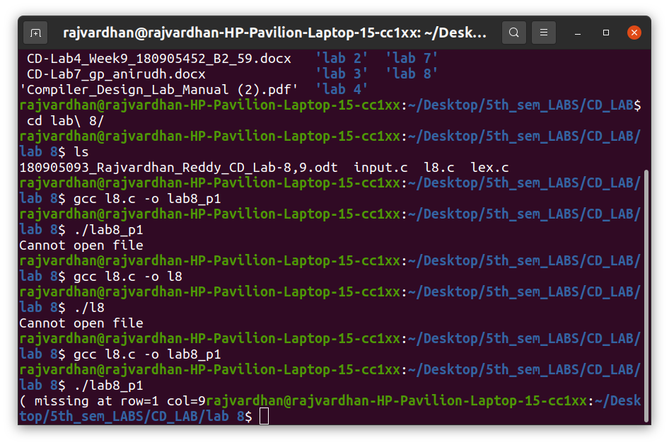

INPUT:

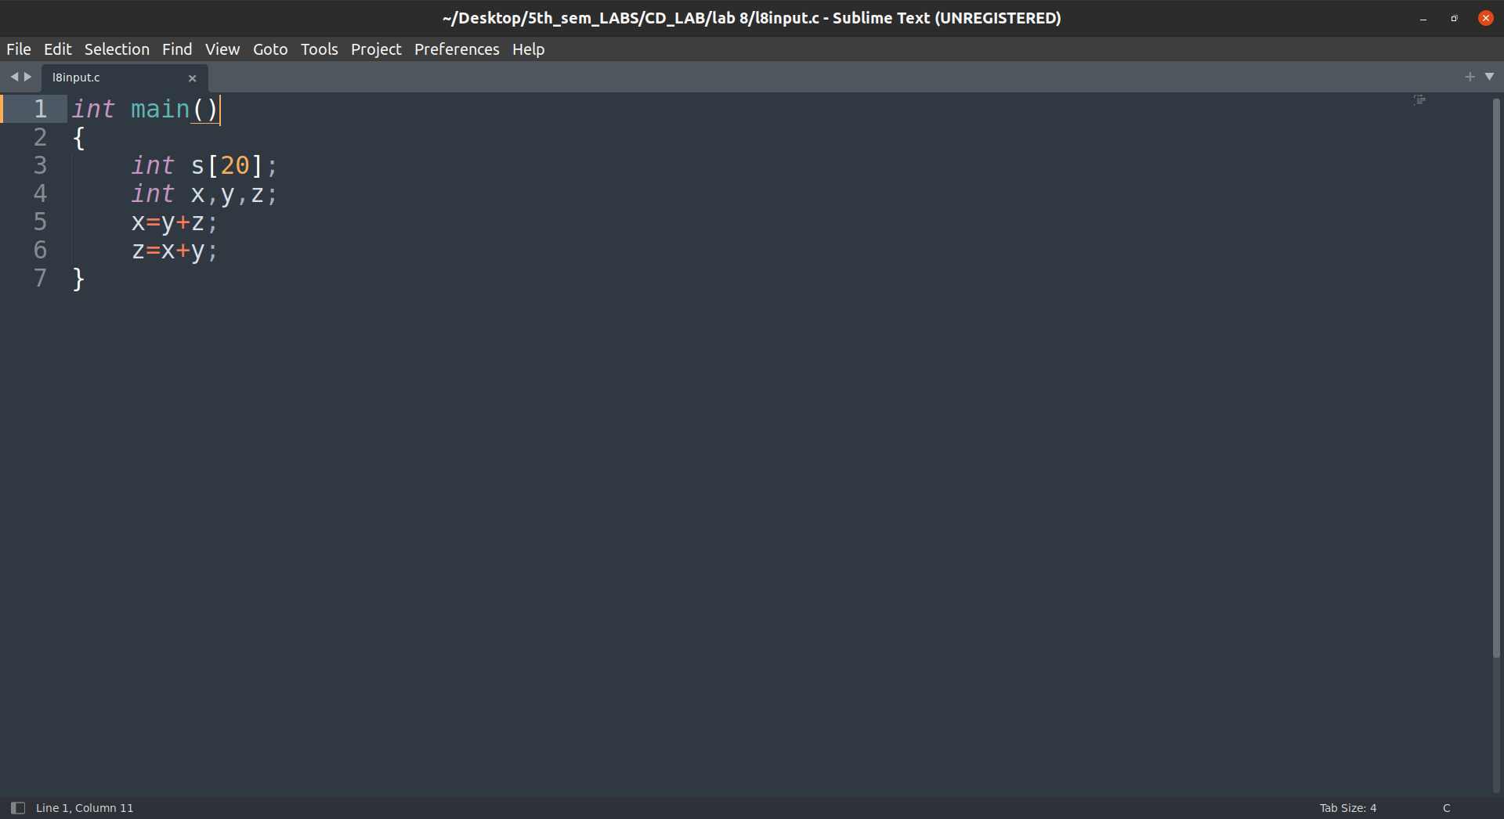
Output :

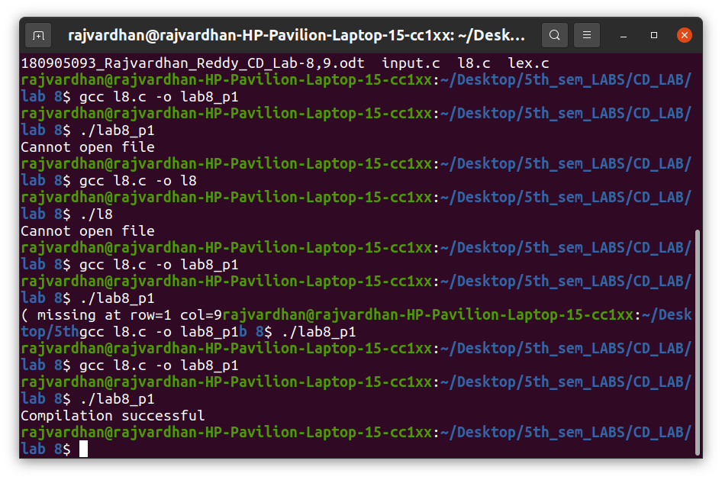

LAB 9 :

P1) Modify the Recursive Descent parser implemented in the previous lab to parse decision making and looping statements with error reporting. Subset of grammar 7.1 is as follows:

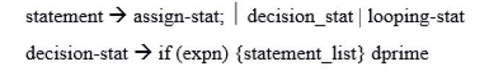

l9.c:

#include "lex.c"

void program();
void declarations();
void datatype();
void idList();
void idListprime();
void idListprimePrime();
void stmtList();
void stmt();
void assignStat();
void expn();
void eprime();
void simpleExpn();
void seprime();
void term();
void tprime();
void factor();
void relop();
void addop();
void mulop();
void decStat();
void dPrime();
void loopStat();

struct token tkn;
FILE *f1;

int main()
{
FILE *fa, *fb;
int ca, cb;
fa = fopen("l9input.c", "r");
if (fa == NULL){
printf("Cannot open file \n");
exit(0);
}

fb = fopen("l9output.c", "w+");
ca = getc(fa);
while (ca != EOF){
if(ca==' ')
{
putc(ca,fb);
while(ca==' ')
ca = getc(fa);
}
if (ca=='/')
{
cb = getc(fa);
if (cb == '/')
{
while(ca != '\n')
ca = getc(fa);
}
else if (cb == '*')
{
do
{
while(ca != '*')
ca = getc(fa);
ca = getc(fa);
} while (ca != '/');
}
else{
putc(ca,fb);
putc(cb,fb);
}
}
else putc(ca,fb);
ca = getc(fa);
}
fclose(fa);
fclose(fb);
fa = fopen("l9output.c", "r");
if(fa == NULL){
printf("Cannot open file");
return 0;
}
fb = fopen("temp.c", "w+");
ca = getc(fa);
while (ca != EOF)
{
if(ca=='"')
{
putc(ca,fb);
ca=getc(fa);
while(ca!='"')
{
putc(ca,fb);
ca=getc(fa);
}
}
else if(ca=='#')
{
while(ca!='\n')
{
ca=getc(fa);
}
}
putc(ca,fb);
ca = getc(fa);
}
fclose(fa);
fclose(fb);

fa = fopen("temp.c", "r");
fb = fopen("l9output.c", "w");
ca = getc(fa);
while(ca != EOF){
putc(ca, fb);
ca = getc(fa);
}
fclose(fa);
fclose(fb);
remove("temp.c");
f1=fopen("l9output.c","r");
if(f1==NULL)
{
printf("Error! File cannot be opened!\n");
return 0;
}

while((tkn=getNextToken(f1)).row!=-1)
{
if(strcmp(tkn.lexeme, "main") == 0)
{
program();
break;
}
}
fclose(f1);
}

void program()
{
if(strcmp(tkn.lexeme, "main") == 0)
{
tkn = getNextToken(f1);
if(strcmp(tkn.lexeme, "(") == 0)
{
tkn = getNextToken(f1);
if(strcmp(tkn.lexeme, ")") == 0)
{
tkn = getNextToken(f1);
if(strcmp(tkn.lexeme, "{") == 0)
{
tkn = getNextToken(f1);
declarations();
stmtList();
if(strcmp(tkn.lexeme, "}") == 0)
{
printf("Compilation successful\n");
return;
}
else
{
printf("ERROR: missing \"}\" at row=%d col=%d\n",tkn.row,tkn.col);
exit(1);
}
}
else
{
printf("ERROR: missing \"{\" at row=%d col=%d\n",tkn.row,tkn.col);
exit(1);
}
}
else
{
printf("ERROR: missing \")\" at row=%d col=%d\n",tkn.row,tkn.col);
exit(1);
}
}
else
{
printf("ERROR: missing \"(\" at row=%d col=%d\n",tkn.row,tkn.col);
exit(1);
}
}
else
{
printf("ERROR: missing \"main\" at row=%d col=%d\n",tkn.row,tkn.col);
exit(1);
}
}

void declarations()
{
if(isdtype(tkn.lexeme)==0)
return;
datatype();
idList();
if(strcmp(tkn.lexeme, ";") == 0)
{
tkn = getNextToken(f1);
declarations();
}
else
{
printf("ERROR: missing \";\" at row=%d col=%d\n",tkn.row,tkn.col);
exit(1);
}
}

void datatype()
{
if(strcmp(tkn.lexeme, "int") == 0)
{
tkn = getNextToken(f1);
return;
}
else if(strcmp(tkn.lexeme, "char") == 0)
{
tkn = getNextToken(f1);
return;
}
else
{
printf("ERROR: missing datatype(int or char) at row=%d col=%d\n",tkn.row,tkn.col);
exit(1);
}
}

void idList()
{
if(strcmp(tkn.type,"IDENTIFIER")==0)
{
tkn = getNextToken(f1);
idListprime();
}
else
{
printf("ERROR: missing IDENTIFIER at row=%d col=%d\n",tkn.row,tkn.col);
exit(1);
}
}

void idListprime()
{
if(strcmp(tkn.lexeme, ",") == 0)
{
tkn = getNextToken(f1);
idList();
}
else if(strcmp(tkn.lexeme, "[") == 0)
{
tkn = getNextToken(f1);
if(strcmp(tkn.type,"NUMBER")==0)
{
tkn = getNextToken(f1);
if(strcmp(tkn.lexeme, "]") == 0)
{
tkn = getNextToken(f1);
idListprimePrime();
}
else
{
printf("ERROR: missing \"]\" at row=%d col=%d\n",tkn.row,tkn.col);
exit(1);
}
}
else
{
printf("ERROR: missing NUMBER at row=%d col=%d\n",tkn.row,tkn.col);
exit(1);
}
}
}

void idListprimePrime()
{
if(strcmp(tkn.lexeme, ",") == 0)
{
tkn = getNextToken(f1);
idList();
}
else
return;
}

void stmtList()
{
if(strcmp(tkn.type,"IDENTIFIER")==0 || strcmp(tkn.lexeme,"if") == 0 || strcmp(tkn.lexeme,"for") == 0 || strcmp(tkn.lexeme,"while") == 0)
{
stmt();
stmtList();
}
return;
}

void stmt()
{
if(strcmp(tkn.type, "IDENTIFIER")==0)
{
assignStat();
if(strcmp(tkn.lexeme, ";") == 0)
{
tkn = getNextToken(f1);
return;
}
else
{
printf("ERROR: missing \";\" at row=%d col=%d\n",tkn.row,tkn.col);
exit(1);
}
}
else if(strcmp(tkn.lexeme, "if")==0)
decStat();
else if((strcmp(tkn.lexeme, "while")==0) || (strcmp(tkn.lexeme, "for")==0))
loopStat();
else
{
printf("%d.%d : Expected \" statement \"\n",tkn.row,tkn.col);
exit(0);
}
}

void assignStat()
{
if(strcmp(tkn.type,"IDENTIFIER")==0)
{
tkn = getNextToken(f1);
if(strcmp(tkn.lexeme, "=") == 0)
{
tkn = getNextToken(f1);
expn();
}
else
{
printf("ERROR: missing \"=\" at row=%d col=%d\n",tkn.row,tkn.col);
exit(1);
}
}
else
{
printf("ERROR: missing IDENTIFIER at row=%d col=%d\n",tkn.row,tkn.col);
exit(1);
}
}

void expn()
{
simpleExpn();
eprime();
}

void eprime()
{
if(strcmp(tkn.type,"RELATIONALOPERATOR")!=0)
return;
relop();
simpleExpn();
}

void simpleExpn()
{
term();
seprime();
}

void seprime()
{
if((strcmp(tkn.lexeme, "+") != 0) && (strcmp(tkn.lexeme, "-") != 0))
return;
addop();
term();
seprime();
}

void term()
{
factor();
tprime();
}

void tprime()
{
if((strcmp(tkn.lexeme, "*") != 0) && (strcmp(tkn.lexeme, "/") != 0)&& (strcmp(tkn.lexeme, "%") != 0))
return;
mulop();
factor();
tprime();
}

void factor()
{
if(strcmp(tkn.type,"IDENTIFIER")==0)
{
tkn=getNextToken(f1);
return;
}
else if(strcmp(tkn.type,"NUMBER")==0)
{
tkn=getNextToken(f1);
return;
}
else
{
printf("ERROR: Expected IDENTIFIER or NUMBER at row=%d col=%d\n",tkn.row,tkn.col);
exit(1);
}
}

void relop()
{
if(strcmp(tkn.lexeme,"==")==0)
{
tkn=getNextToken(f1);
return;
}
else if(strcmp(tkn.lexeme,"!=")==0)
{
tkn=getNextToken(f1);
return;
}
else if(strcmp(tkn.lexeme,"<=")==0)
{
tkn=getNextToken(f1);
return;
}
else if(strcmp(tkn.lexeme,">=")==0)
{
tkn=getNextToken(f1);
return;
}
else if(strcmp(tkn.lexeme,"<")==0)
{
tkn=getNextToken(f1);
return;
}
else if(strcmp(tkn.lexeme,">")==0)
{
tkn=getNextToken(f1);
return;
}
else
{
printf("ERROR: Expected RELATIONAL OPERATOR or NUMBER at row=%d col=%d\n",tkn.row,tkn.col);
exit(1);
}
}
void addop()
{
if(strcmp(tkn.lexeme,"+")==0)
{
tkn=getNextToken(f1);
return;
}
else if(strcmp(tkn.lexeme,"-")==0)
{
tkn=getNextToken(f1);
return;
}
else
{
printf("ERROR: Expected \"+\" or \"-\" at row=%d col=%d\n",tkn.row,tkn.col);
exit(1);
}
}
void mulop()
{
if(strcmp(tkn.lexeme,"*")==0)
{
tkn=getNextToken(f1);
return;
}
else if(strcmp(tkn.lexeme,"/")==0)
{
tkn=getNextToken(f1);
return;
}
else if(strcmp(tkn.lexeme,"*")==0)
{
tkn=getNextToken(f1);
return;
}
else
{
printf("ERROR: Expected \"*\" or \"/\" or \"%%\" at row=%d col=%d\n",tkn.row,tkn.col);
exit(1);
}
}

void decStat()
{
if(strcmp(tkn.lexeme, "if")==0)
{
tkn = getNextToken(f1);
if(strcmp(tkn.lexeme, "(") == 0)
{
tkn = getNextToken(f1);
expn();
if(strcmp(tkn.lexeme, ")") == 0)
{
tkn = getNextToken(f1);
if(strcmp(tkn.lexeme, "{") == 0)
{
tkn = getNextToken(f1);
stmtList();
if(strcmp(tkn.lexeme, "}") == 0)
{
tkn = getNextToken(f1);
dPrime();
return;
}
else
{
printf("ERROR: missing \"}\" at row=%d col=%d\n",tkn.row,tkn.col);
exit(1);
}
}
else
{
printf("ERROR: missing \"{\" at row=%d col=%d\n",tkn.row,tkn.col);
exit(1);
}
}
else
{
printf("ERROR: missing \")\" at row=%d col=%d\n",tkn.row,tkn.col);
exit(1);
}
}
else
{
printf("ERROR: missing \"(\" at row=%d col=%d\n",tkn.row,tkn.col);
exit(1);
}
}
else
{
printf("ERROR: missing \"keyword\" at row=%d col=%d\n",tkn.row,tkn.col);
exit(1);
}
}

void dPrime()
{
if(strcmp(tkn.lexeme, "else")==0)
{
tkn = getNextToken(f1);
if(strcmp(tkn.lexeme, "{") == 0)
{
tkn = getNextToken(f1);
stmtList();
if(strcmp(tkn.lexeme, "}") == 0)
{
tkn = getNextToken(f1);
return;
}
else
{
printf("ERROR: missing \"}\" at row=%d col=%d\n",tkn.row,tkn.col);
exit(1);
}
}
else
{
printf("ERROR: missing \"{\" at row=%d col=%d\n",tkn.row,tkn.col);
exit(1);
}
}
else
return;
}

void loopStat()
{
if(strcmp(tkn.lexeme, "while")==0)
{
tkn = getNextToken(f1);
if(strcmp(tkn.lexeme, "(") == 0)
{
tkn = getNextToken(f1);
expn();
if(strcmp(tkn.lexeme, ")") == 0)
{
tkn = getNextToken(f1);
if(strcmp(tkn.lexeme, "{") == 0)
{
tkn = getNextToken(f1);
stmtList();
if(strcmp(tkn.lexeme, "}") == 0)
{
tkn = getNextToken(f1);
return;
}
else
{
printf("ERROR: missing \"}\" at row=%d col=%d\n",tkn.row,tkn.col);
exit(1);
}
}
else
{
printf("ERROR: missing \"{\" at row=%d col=%d\n",tkn.row,tkn.col);
exit(1);
}
}
else
{
printf("ERROR: missing \")\" at row=%d col=%d\n",tkn.row,tkn.col);
exit(1);
}
}
else
{
printf("ERROR: missing \"(\" at row=%d col=%d\n",tkn.row,tkn.col);
exit(1);
}
}
else if(strcmp(tkn.lexeme, "for")==0)
{
tkn = getNextToken(f1);
if(strcmp(tkn.lexeme, "(") == 0)
{
tkn = getNextToken(f1);
assignStat();
if(strcmp(tkn.lexeme, ";") == 0)
{
tkn = getNextToken(f1);
expn();
if(strcmp(tkn.lexeme, ";") == 0)
{
tkn = getNextToken(f1);
assignStat();
if(strcmp(tkn.lexeme, ")") == 0)
{
tkn = getNextToken(f1);

if(strcmp(tkn.lexeme, "{") == 0)
{
tkn = getNextToken(f1);
stmtList();
if(strcmp(tkn.lexeme, "}") == 0)
{
tkn = getNextToken(f1);
return;
}
else
{
printf("ERROR: missing \"}\" at row=%d col=%d\n",tkn.row,tkn.col);
exit(1);
}
}
else
{
printf("ERROR: missing \"{\" at row=%d col=%d\n",tkn.row,tkn.col);
exit(1);
}
}
else
{
printf("ERROR: missing \")\" at row=%d col=%d\n",tkn.row,tkn.col);
exit(1);
}
}
else
{
printf("ERROR: missing \";\" at row=%d col=%d\n",tkn.row,tkn.col);
exit(1);
}
}
else
{
printf("ERROR: missing \";\" at row=%d col=%d\n",tkn.row,tkn.col);
exit(1);
}
}
else
{
printf("ERROR: missing \"(\" at row=%d col=%d\n",tkn.row,tkn.col);
exit(1);
}
}
else
{
printf("ERROR: missing \"keyword\" at row=%d col=%d\n",tkn.row,tkn.col);
exit(1);
}

}

Input:

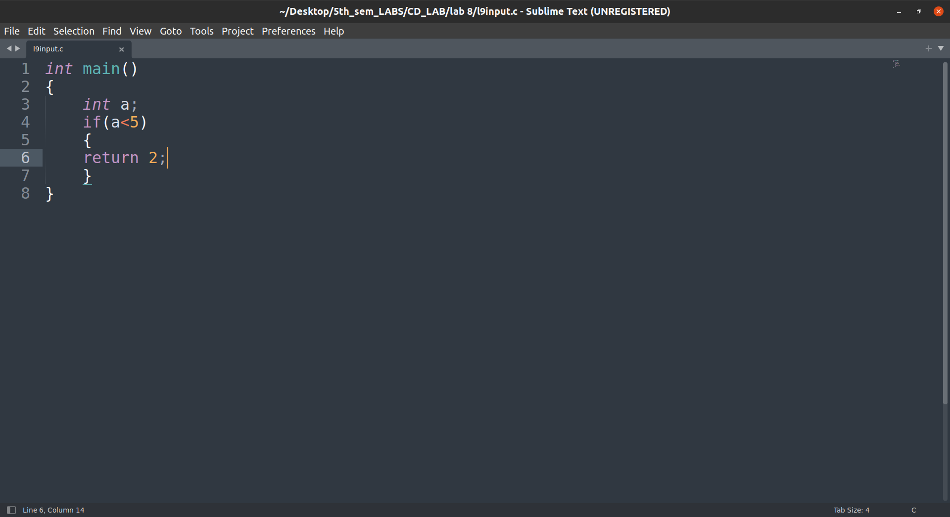

Output:
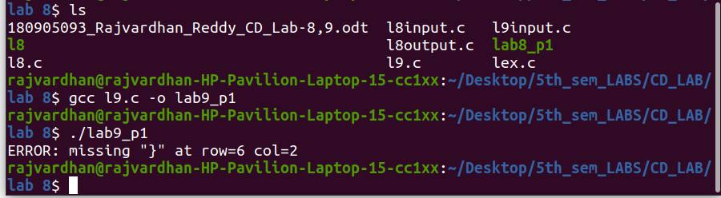

Input:

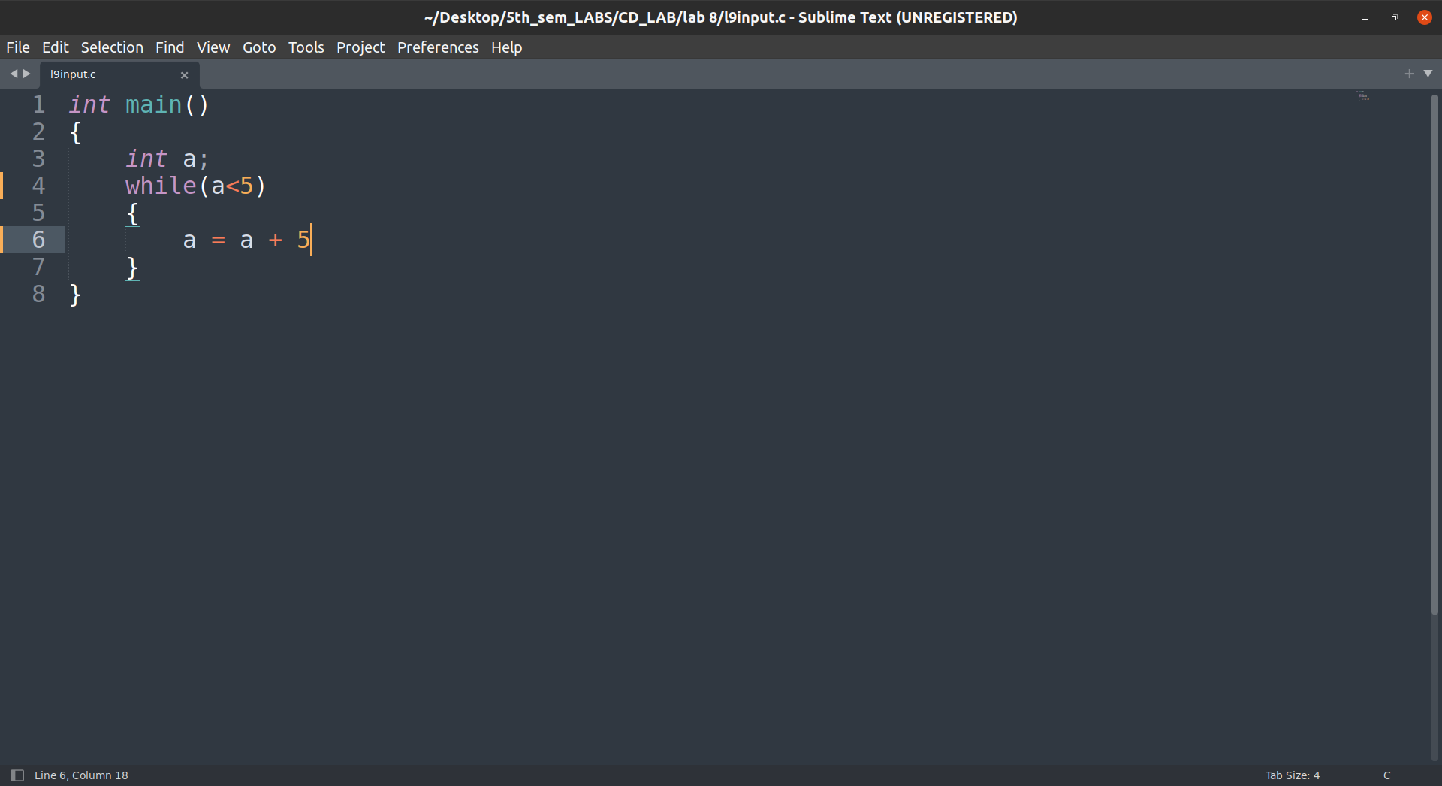
Output:

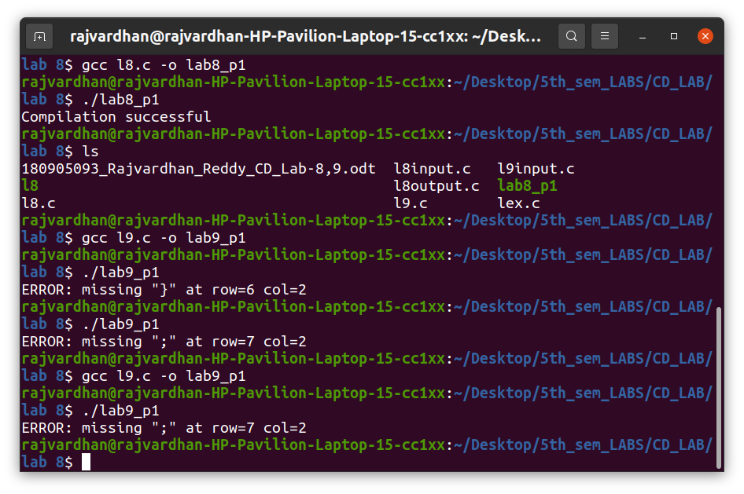
Input:

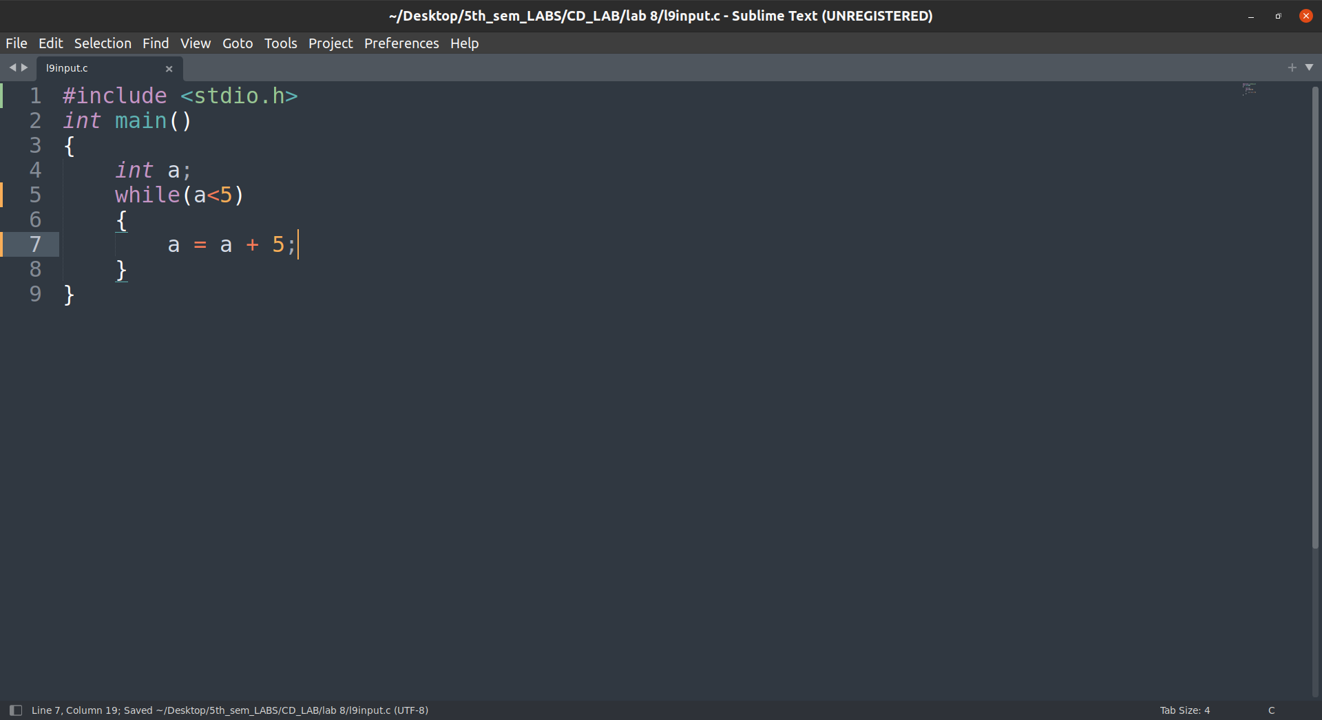
Output:

